

**Department of Computer Science & Engineering**

**CA2 GEN AI**

**B.TECH -7th Semester (Session 2021-25)**

**Name: Manmeet Oberoi (PRN: 21070521039)**

Q:1 Generate a model in Python for representation of a bank account of type savings and

balance along with transactions of deposit and withdrawals and currently create a program to

generate 100 accounts with Random balance and transactions for no. of months and no. of

transactions with a seed value of amount. Print all 100 accounts with the last balance and

organize them by lowest to highest balance.

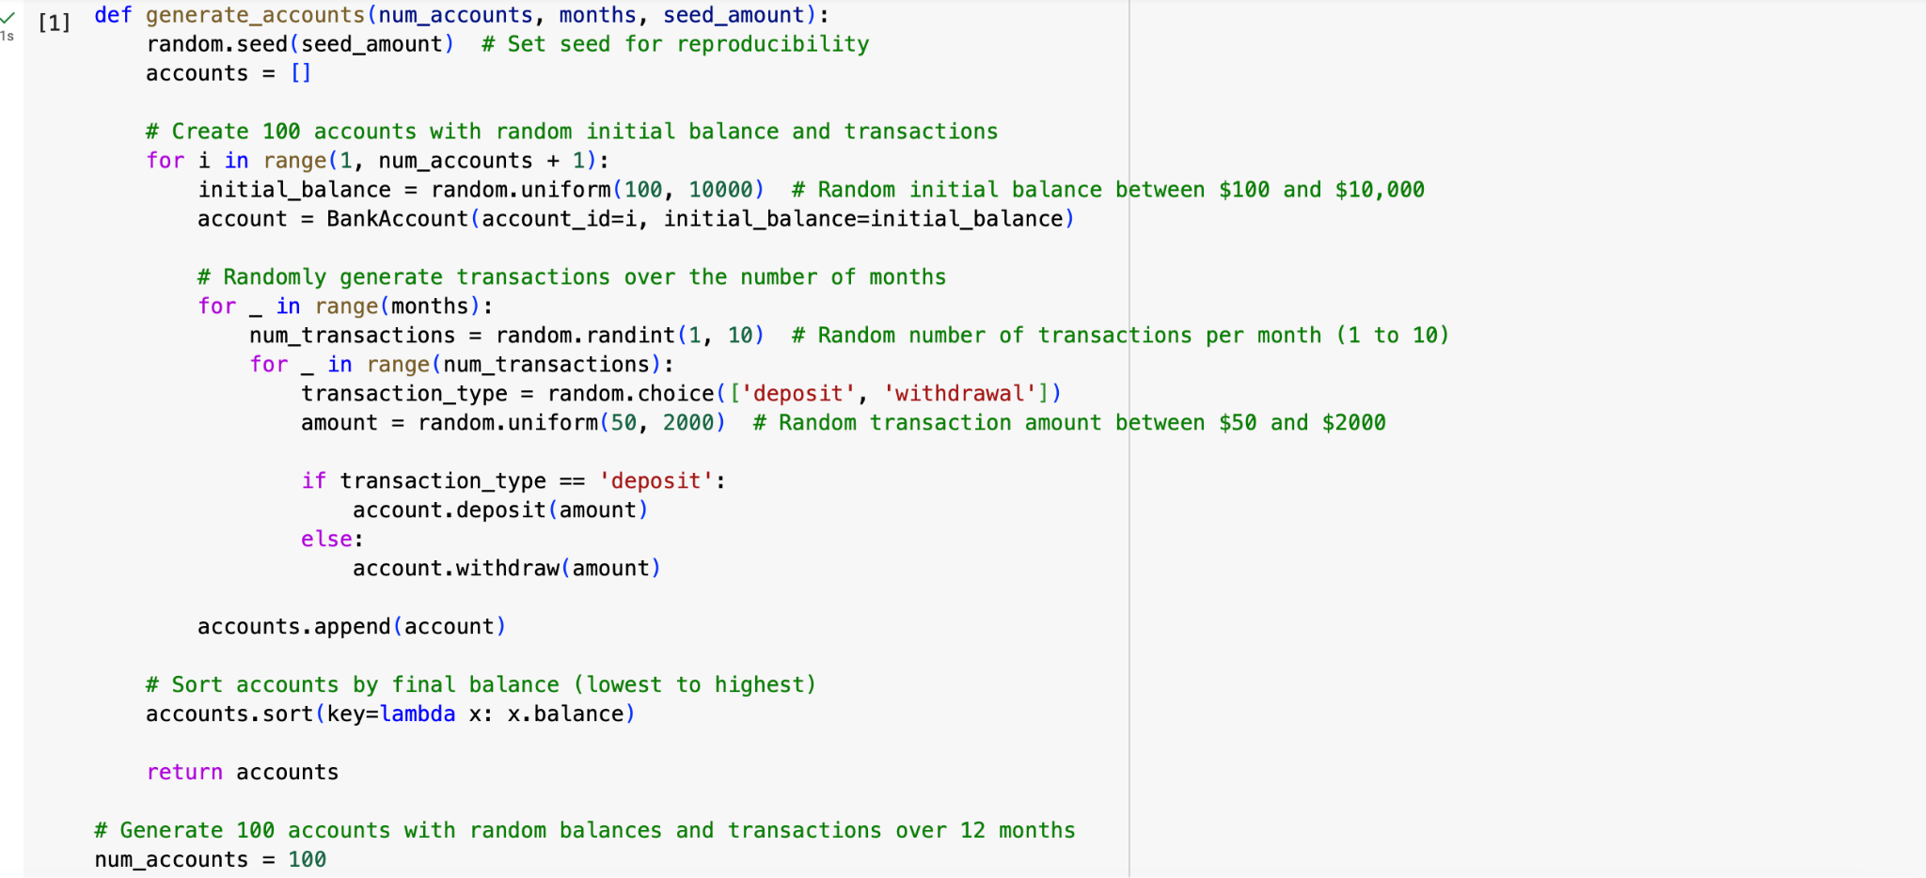

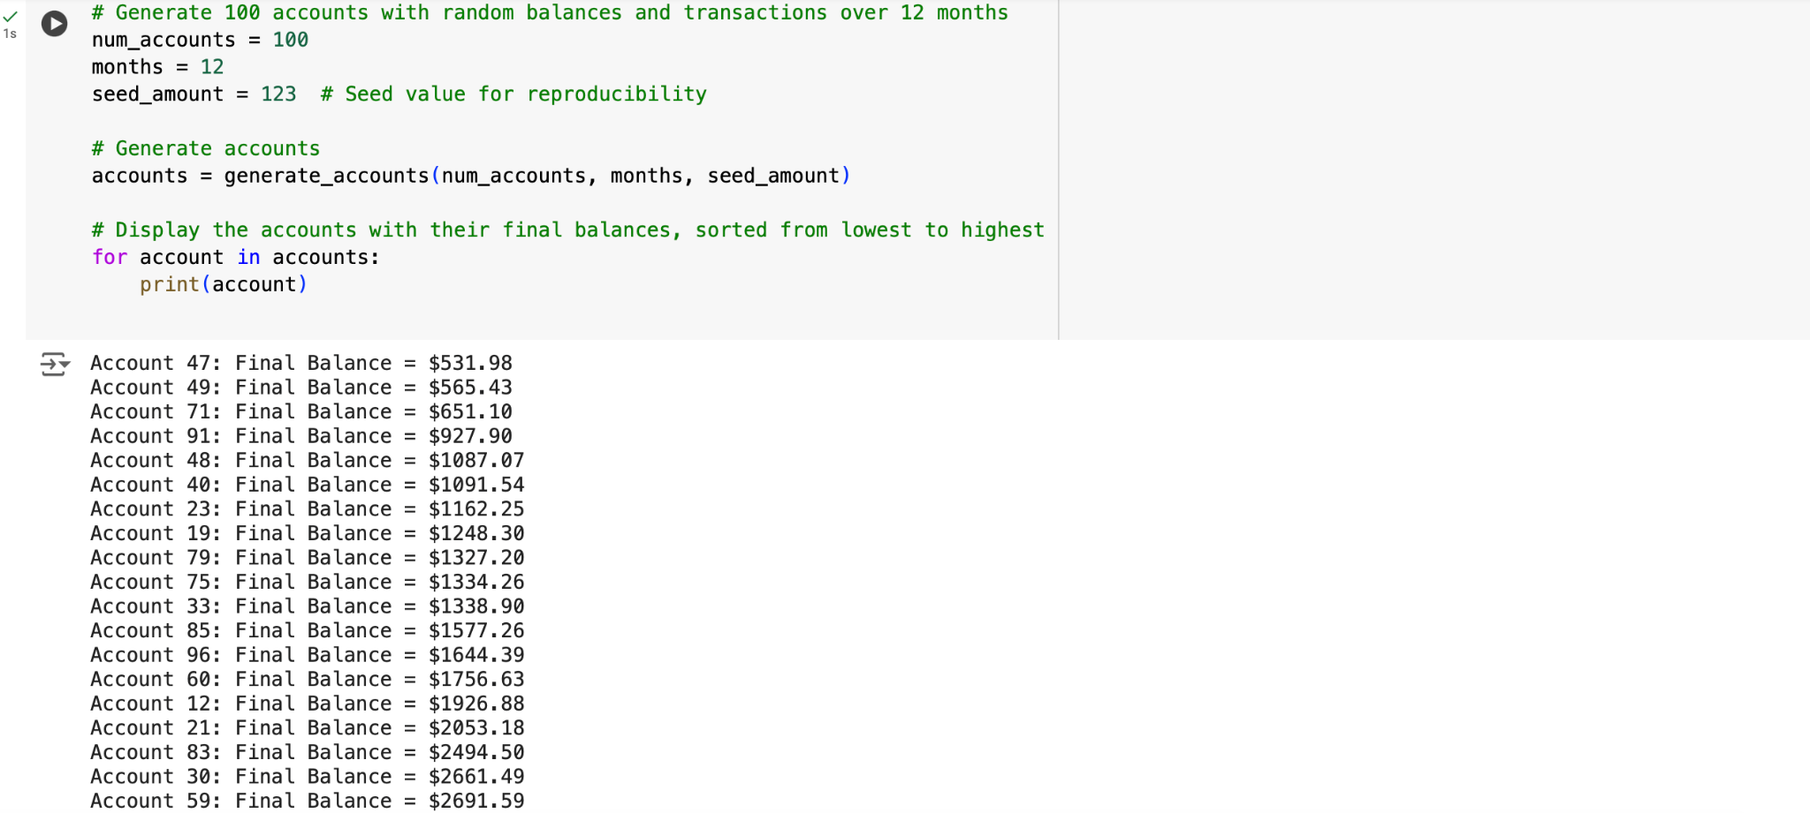

Q6. Generate a model to represent a mathematical equation, write a program to parse the

equation, and ask for input for each parameter.

